

The Churches Visitor and Tourism Association

Members’ Newsletter

September 2019

2019 Symposium and AGM – Saturday19 October 10.00am – 4.00pm
Central Hall, Oldham Street, Manchester M1 1JQ

‘Open All Hours – for Whom? When? Why?’

The programme for the above is almost complete. During the morning we shall welcome presentations from:

Canon Michael Everitt, formerly Archdeacon of Lancaster and recently installed Canon Pastor of Durham Cathedral, who was due to make a presentation at the recent Diocesan Advisory Committee’s Conference on Reimagining Church Buildings;

Jakki Bavin, Mission Partnership development Worker in Sheffield Diocese, working with a number of parishes and clergy in central Sheffield particularly focusing on the involvement of the Church in regeneration projects;

Fran Bell, Church Development Officer in Lincoln Diocese, who will speak from a rural perspective on the significance of church buildings to communities;

The Revd. Dr. Sue Lucas, Team Rector based at St. Bartholomew’s East Ham, London working within a heavily multi-faith setting;

During the afternoon we shall welcome:

Alison Dalton, Church Related Community Work Minister, Building Bridges Project, Bolton, a partnership project between the URC, Methodist and Anglicans and a number of secular organisations working with different age groups. Alison will also talk about the trail for which she was responsible in Poole prior to coming to Bolton;

The Revd. David Ireland, Union Street URC in Oldham Town Centre which has experienced years of blight and failed development projects, now located in a multicultural setting with many challenges. In addition to being a minister David is also an architect and involved with Francis House Children’s Hospice.

There is the possibility of another presenter, but I am anxious to provide sufficient time for discussion amongst the attendees regarding the very important issues which this theme and the various viewpoints offered by the presenters will be putting before us. The purpose of the Symposium is that those who come should feel themselves as participants as well as recipients. There are still a number of places available so although booking is scheduled to be closed by Thursday 10 October, consideration will be given to late applicants up until Tuesday 15 October. Refreshments including lunch will be provided and CVTA’s AGM will occupy approximately 20 minutes in the middle of the day. I am attaching a further booking form.

With every edition of the Newsletter I always invite readers to contribute articles. I am delighted that with this edition Mike Brogden, Secretary’s of Shropshire’s Mayflower Children, has submitted the article below to which he invites readers to respond. It would be really good if this were not the one and only article to appear in this way, and if we were to get to the point whereby this Newsletter could be used as a forum for debate with regard to issues appropriate to the churches within today’s society, particularly since there is considerable debate going on to which I hope the Symposium will contribute regarding the contribution of the churches within an increasingly multi-cultural and multi-faith society. My sense is that the days of finding straightforward answers to the questions regarding the Church’s ministry and mission or as the ACORA Report of 1992 put it ‘Mission Through Ministry’ are no longer satisfactory. We have to be ready to think through much more carefully and seriously the contribution of our churches to our society today.

Next edition: So, if any of you have items that you would like included in the November 2019 Newsletter please ensure that they are received here by Thursday 14 November 2019 at the latest.
E-mail: canonjbrown@mac.com
Hard copy: 556 Galleywood Road, Chelmsford, Essex CM2 8BX
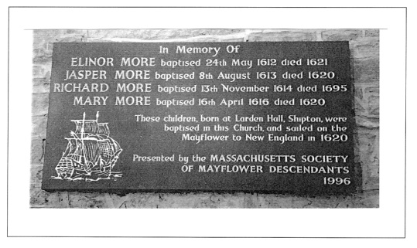
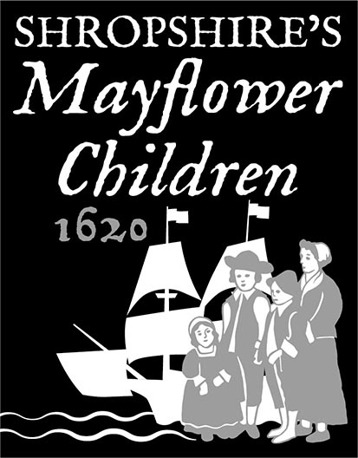

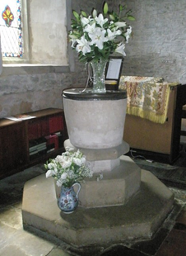

Shropshire’s Mayflower Children

Visitors to the parish church of St James, Shipton, near Much Wenlock, in deepest rural Shropshire, find a plaque to the four young children of Katharine More who were banished by her husband, Samuel, to America on the Mayflower in 1620. The story behind this plaque is of family intrigues to consolidate two estates, the arranged marriage of two, ill-matched cousins, the claimed but unsubstantiated betrothal of Katharine to the son of one of her father’s tenant farmers, Jacob Blakeway, the birth of the four children who were declared not to be his by Samuel and the cruel banishment of the children. Both Katharine and Jacob then disappear from the records so we do not know what happened to them.

The church records show the baptisms of the four children that would have taken place in the very font that exists today, along with the marriage of Katharine and Samuel. Jacob Blakeway’s baptism is recorded in the parish register in the neighbouring church of St Michael and All Angels, Stanton Long. He and his parents lived in neighbouring Brockton. Only one of the children, Richard, survived the crossing and the hardships of the first year in America. He has his own interesting story as a sea captain, merchant adventurer and privateer.

We invite interested parties to visit in 2020 when we commemorate the tale of the More children. In addition to Shipton church and its unique story, the area is of great interest for its market towns of Much Wenlock and Ludlow and its historic buildings such as Stokesay Castle, Wenlock Priory and Hopton Castle, scene of another disreputable act by Samuel More in the Civil War.

If your group would be interested in a day trip or longer in 2020, we can offer help with planning and suggestions of hostelries, along with providing a guide to tell the More story.

Please contact Mike Brogden, Secretary, Shropshire’s Mayflower Children, by email to mike@brogden.info phone 01584 841649. Website: www.shropshiresmayflowerchildren.com

